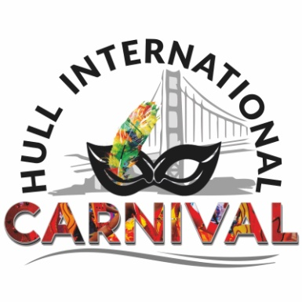
HullInternational Carnival Participant Form– to be completed by any groups or individual who wants to take part pre or on the Carnival day Sunday 1st September 2019, Hull City Centre
The Hull International Carnival will take place within the Freedom Festival on Sunday 1st September 2019. The event includes a Street procession of performers, street arts performances, a live stage and many opportunities to volunteer. The artistic programme is developed by Pax Nindi, FRSA, and Artistic Director.

If you would like to take part in the Carnival, please complete this application form and email it to the Carnival Chairman Dr Tapan Mahapatra info@hullinternationalcarnival.org.uk by 5pm on Friday 15th July 2019 or call 07405499881

We will assess all applications and will select a limited number of groups and individuals to take part in the Carnival.

Please note that we are not able to provide any financial support towards your participation. However depending on availability of grant funds there may be some support towards expenses to be confirmed in due course.

Theme of the Carnival: Cultural Sharing& Traditions
Name of organisation
Leader/Coordinator’s name
Email
Phone
What would you like to do or offer Carnival e.g. Volunteer, Banner or Costumemakingetc
How many people will be involved?
Description of proposed activity
Names of artists, DBS checks etc.
If proposing performances please outline what is involved bearing in mind this year we are only doing a parade
If you are funded let us know funder or sponsor
Carnival Centres Costume making, Floats Banners, dance etc | To be announced in July, August 2018

