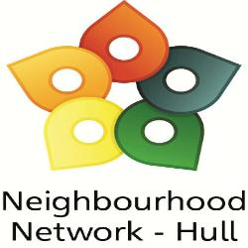
Neighbourhood Network ‘Rewards’ 2020

We all know 2020 has brought its challenges and it’s changed the way we now do things. Unfortunately we cannot host our ‘normal awards’ event in October as we hoped, but the Neighbourhood Network are still looking to ‘reward’ its hardworking member groups by granting some of your wishes.

We are offering our registered members the opportunity to apply to us for items on their wish list that would help with their group’s development and achieving their aims. We want to recognise and celebrate the important part Neighbourhood Network groups have in contributing to their local communities; making them safer to live, work and play in and a few lucky groups will have their wishes granted.

By granting your wishes we want to aid your group in achieving one or more of the following:

- Helping to create self-sustaining and safer communities
- Preventing fewer victims of crime
- Encouraging integration and engagement within your communities
- Enabling communities to take a more active role
- Supporting victims of crime
- Creating safer environments in which to live, play, work
- Promoting health and well-being
- Supporting the most vulnerable within our communities

Please fill in the below to apply for our 2020 Rewards:

Contact details (We may contact you to discuss your application)
Name of your group /organisation………………………………………………………………………………………………
Main contact name: ……………..……………………….......Telephone: ....................................................
Address:..………………..……………………………………………Email: ……........................……..........................

- Please tell us in no more than 300 words about your group/organisation and what your aims are?

- What item(s) would you like to be gifted by the NN, please include quantity and costings if possible?

- What positive difference would this item(s) make to you group/organisation? (please make reference to the bullet points listed overleaf)

The closing date for entries is Friday 9th October 2020

Applications will be considered by a panel and groups will be contacted only if they are successful in their wish being granted. The NN has a limited budget (up to £150 per group) and in some cases it may make a contribution towards items.
The charity will consider those applications that most fit its aims and objectives.

Please return all entry forms via email to: office@nnetwork.org.uk

