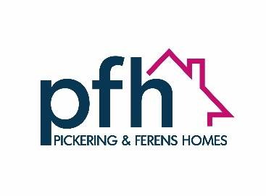
PFH Interchange Scheme
Try us for size!
Have you heard about PFH’s Interchange scheme?
It’s all about giving people the opportunity to experience what it’s like to live in a PFH Retirement Plus apartment, without making any commitment. In other words, “Try Before You Rent!”
If you and/or your partner are 60 and over, you can stay in a Retirement Plus apartment for a short time to experience what it’s like and whether it’s for you. You can take full advantage of the facilities and services on offer, without having to make any commitment. If you like it, you can apply to live in one of your own!
We have set aside two apartments, one at Broadway Manor in east Hull and one at Christopher Pickering Lodge in west Hull, for the Interchange scheme.
What is Retirement Plus (R+)?
PFH have a total of five R+ schemes across Hull. They are designed for people aged 60 and over who want to live comfortably, happily, securely and independently. They are perfect for those who want to make the most of their retirement. R+ is all about promoting independence, so whilst PFH staff can support and guide you, we will not provide care or meals. All apartments are self-contained and private. Our R+ developments are below.
- Ada Holmes Circle, Greenwood Avenue, Hull, HU6 9PB
- Broadway Manor, The Broadway, Hull, HU9 3PN
- Christopher Pickering Lodge, Hessle High Road, Hull, HU4 6RS
- Humber View, Victoria Dock, Hull, HU9 1SZ
- Malin Lodge, Maybury Road, Hull, HU9 3LH
The benefits and facilities available in R+ schemes, to count a few, are as follows:
- Fully independent accommodation
- Scheme Manager available during office hours Monday to Friday to support and advise residents
- A busy social calendar of events taking place in the scheme
- A variety of health and wellbeing initiatives to keep you mentally and physically healthy
- Excellent services including repairs
- A feeling of community and security, with secure controlled door entry system
- Your own private self-contained apartment (living room, kitchen, bedroom, bathroom)
- A host of facilities including a lounge, which is a shared space, perfect for getting together to enjoy a coffee, tea and cake or share creative activities or hobbies. There is also a laundry, hairdressing salon and attractive gardens)
- Telecare options to optimize your safety and security
Where are the Interchange properties located?
The apartments set aside for the Interchange scheme are at Broadway Manor in east Hull and Christopher Pickering Lodge in west Hull. They are one-bedroom apartments and access to them does not require climbing a flight of stairs. They have been set aside specifically for those who are keen to try out living in one of these apartments and taking full advantage of all the facilities and social activities, without having to make any commitment.
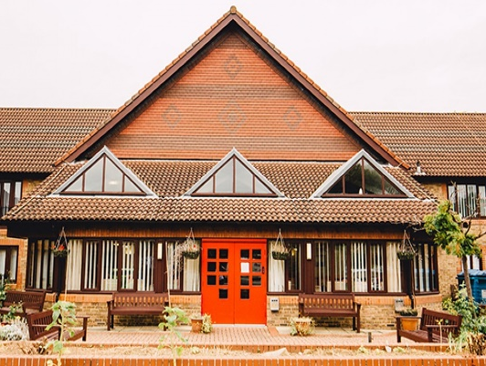
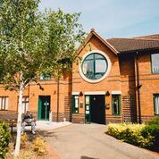
Broadway Manor, East Hull Christopher Pickering Lodge, West Hull
How long can I stay for?
You can stay for up to three weeks. During this time, it is hoped that you will have had the time to get a genuine feel for the apartment, the building, the services on offer, the local area and the overall feeling of the scheme, and whether it suits you. If during the time you are there you decide that you do not want to stay for the full 3 weeks, we ask that you let us know immediately, so that we can arrange to check the property and get the keys back from you.
What happens to my own property?
Nothing. The interchange scheme does not affect your current property or your benefits. Everything will be just as it was when you return home.
Eligibility
In order to qualify, you will need to meet the following criteria:
- Be a single person or couple, both aged 60 or over
- Live in, or have been born in, Hull or the East Riding of Yorkshire
- Have less than £200,000 in capital/savings combined
- Not be in temporary accommodation or currently homeless
How much does it cost?
Nothing. You do not have to pay any Weekly Maintenance Contribution (rent) or for any of the services whilst you’re on the trial. It will not affect your housing benefit or any other benefits at your current property, nor any other benefits that you may be entitled to.
Who should I inform?
If you receive care, you need to make the care provider aware of your temporary change of address. You may also need to cancel or change any deliveries you usually receive, such as milk or papers. If you will need any of your usual adaptations supplied by NRS, you need to arrange this with them. When you leave, you will also need to arrange for their collection before you vacate the apartment.
What will I need to bring?
The properties are fully furnished but you will need to bring some things. Think of it as going on holiday; what would you normally take with you? An indication of what you’d need to take is as follows:
- Bedding (duvet, sheets, blankets, pillows)
- Towels (bath sheet and hand towel)
- Clothes
- Toiletries
- Food
- Toilet roll
What PFH will provide
- Dish cloths/pan scrub
- Tea towels
- Washing up liquid
- A bin liner
- Laundry tablet
Remember, you can always pop home for things and there are shops very close by for anything else you need.
I’m interested, what do I do?
It is likely that you have been provided with this leaflet by an Occupational Therapist, GP, Social Worker, Support Worker or other agency. They will complete a referral form (which you will be asked to sign) and they will send it to us. We will contact you to advise you of the next steps. Please remember that there may be other people waiting, and we prioritise based on referral date order.
You can also contact us directly however if we have a list if interested people, we will give priority to people who have been referred by specialist agencies.
What happens if I love living there and would like to stay?
You cannot remain in this property as it is furnished and has been set aside for the Interchange Scheme. But don’t worry, we will arrange for our Waiting List Coordinator who will discuss the next steps with you and complete an application to apply to live permanently in a Retirement Plus apartment.
Evaluation
Because this is a new project, we have asked researchers from the University of Hull to carry out some research. This is to find out:
- What people think about the scheme
- What works well
- Anything that doesn’t work well, or which could be changed
- Whether the trial visits help people make decisions about future plans and accommodation.

Everyone applying will be invited to take part. We would love to hear your views, however it is entirely up to you whether you take part and the decision will not affect your taking part in the trial or any future accommodation with PFH. Information about you will be kept confidential. We will provide further information on the research should you take part in the Interchange scheme.

What are my responsibilities?
When occupying one of the Interchange apartments, we ask that you:
- Keep it clean and tidy
- Report any repairs or faults to PFH
- Report any breakages or damage caused to any of the items in the apartment
- Ensure the property is completely cleared of all your belongings and left clean and tidy on the day you leave; any items left may be disposed of as we will be preparing the apartment for the next interchange resident.
- Ensure that the keys are returned by noon on your final day
Any Other Questions?
Don’t hesitate to give us a call on (01482) 223783, or email us at info@pfh.org.uk if you have any questions.

