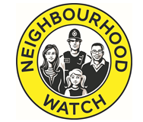
Neighbourhood Watch Network
WG07, Vox Studios
1 – 45 Durham Street
Vauxhall
SE11 5JH

4th November 2020
Dear Association Leads,

With the announcement of a second national lockdown beginning this week in England and the lockdown in Wales due to end next week, the severity of restrictions is high as there is significant concern about the virus spreading more rapidly. It is vital that our Coordinators and volunteers follow the government guidance and ensure they continue to keep themselves safe. Supporting our communities and particularly the vulnerable, in ways that does not put ourselves or others at risk, was something that we did incredibly well in different ways during the first lockdown.

As I mentioned last month the fatigue relating to the Covid-19 crisis is well known so it is important that we continue to link up with and support our neighbours and the isolated and vulnerable. The Central Support Team will be helping you continue with this over the lockdown and winter period. We will be sharing in our November newsletter information on The Calling Tree that was so well received previously as well as other ideas and good practice.

In non Covid-19 news will shortly be launching a social media campaign on Password Security. We have been liaising with the National Cyber Security Centre and the Home Office to ensure our campaign carries the latest information and advice. The campaign which will be delivered over social media will target non-members and contain 3 simple steps to ensure our important passwords are secure to reduce the possibility of being hacked. We will be sharing the campaign resources with Association Leads and Coordinators soon so the simple messages can be shared widely within our own networks. We will report on the reach and impact of the campaign and hope it will be as successful as our burglary campaign.

Following feedback from the Zoom calls in October with our Chair, Ian Bretman, and Association Leads we are making amendments to the 5-year strategy and the supporting documents. We are also preparing for the AGM on the 24th November. Kit Malthouse will be speaking at the AGM and we will use an electronic voting system. This will require voting members to have access to a smart phone while accessing the AGM via another device such as a laptop, desktop or tablet. We will email further information and clarity on this in the next week. Given the AGM will be online this year we hope it will be useful and engaging while looking forward to be able to meet in person when this is possible.

The response to this year’s Neighbour of the Year Award has been brilliant with over 800 nominations! The award, which we run with Coop Insurance, is now in it’s third year and as well as the usual Neighbour of the Year Award, this year there is also a Young Neighbour of the Year Award. It may well be that the upsurge in neighbourliness we have witnessed this year as part of people’s response to Covid-19 and the incredible support itself has led to the increase in nominations. Whatever the reason, it is clear evidence that people are keener than ever to recognise the support neighbours have given to each other and their communities this year. The winners will be announced in early December with as much media attention and support as we can generate.

The first Neighbourhood Watch Impact Report covering 2019/20 will be released in the next few weeks. This will be an annual report that will highlight the work and impact of Neighbourhood Watch over the previous year. The report will be available electronically and we will be posting 2 printed copies to each Association. We encourage you to send a copy (printed or electronic) to the Police and PCC or whoever you think best. The Central Support Team will be sharing the report to all the national stakeholders that may benefit. We hope the Impact Report is an aid to fundraising, publicity and a celebration of the work of the movement.

We are undertaking a website review that will lead to improvements to the new website. We have taken input from a range of users and stakeholders, looked at the usage on different pages, and undertaken a digital survey from website users. We aim to implement the improvements over the next few months and hope that following this people using the site for the first time will be able to access crime prevention information and advice quickly and easily, and Coordinators and Associations will be able to access the information and support they need easily.

As mentioned at the start of this letter the winter period will be challenging for all communities across England and Wales as we continue to respond to the Covid-19 crisis. It is likely there will be divisions about how different people think the government and individuals should be responding to the crisis. However from the great work undertaken already by Neighbourhood Watch during this crisis to ensure communities stay connected and the most vulnerable are safe and supported, we are well placed to continue to support our communities to get through the challenges ahead.

Please continue to let us know what is happening locally, and share this letter with your Coordinators, members, and partners.

Yours faithfully and stay safe,
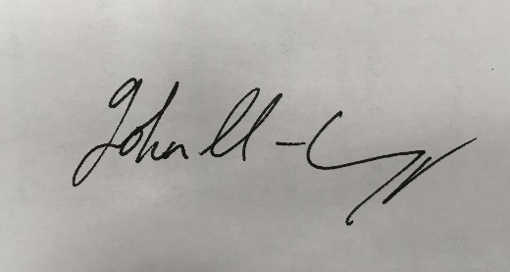
John Hayward-Cripps
CEO, Neighbourhood Watch Network

