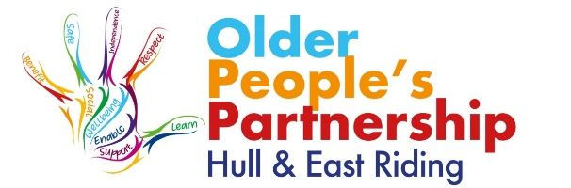

INVITATION FOR EXPRESSIONS OF INTEREST TO BECOME A TRUSTEE
The Older Peoples Partnership was established in 2014, and became a charity in 2017. The partnership brings together 50 organisations that deliver services to older people in Hull and East Riding of Yorkshire and allows sharing of best practice, networking opportunities and an annual Celebration of Older People week which includes International Older People’s Day on 1st October each year.
The Older Peoples Partnership Hull and East Riding is a Charitable Incorporated Organisation (CIO). The activities are overseen by a Board of Trustees who are also Directors of the charity and ultimately responsible for the management of the charity.
We have a small, dedicated management team who are responsible for the day to day running of the charity and activities.
The Board of Trustees determines the strategy, sets the goals and reviews the outcomes for the charity.
It is involved with all aspects of our activity and Board members are required to be directly involved in the expert led key advisory committees that guide our plans to meet our charitable objects to promote and develop services for older people.
We are also seeking those with other relevant skills and experience:-
- Strategic Planning
- Project Management
- Marketing, Social Media and PR
- Health, Social Care and VCS for Older People Services including Lived Experience
- Grant and Funding Applications
Key duties
- Trustees are Directors of the charity and need to be familiar with and understand the governance requirements.
- Trustees should endeavor to attend Board of Trustee meetings.
- Trustees will be asked to be a member of Older Peoples Partnership Hull and East Riding working groups – for example: Planning meetings and Events. Other sub groups are formed from time to advise on key areas of our activities

Charity Commission Trustee guidelines
If you are interested in becoming a Trustee we strongly advise you to consult the Charity Commission’s website and read ‘The Essential Trustee’.www.charitycommission.gov.uk
Expenses
The role is voluntary, however any agreed expenses can be reimbursed.
How to apply
In the first instance please send a letter of interest by E mail setting out your background and experience and why you feel you will be an asset to the charity.
Please contact info@olderpeoplespartnership.org.uk with your Expression of Interest.
The next step for those with suitable experience will be an informal meeting with two members of the board to fully explain the role and the process for application.
Closing date for expressions of interest is 31st January 2021

