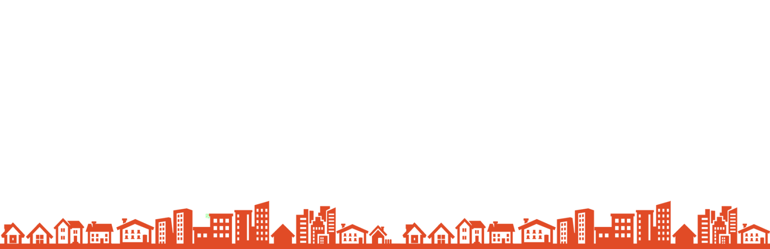
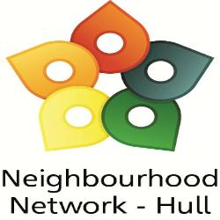
Neighbourhood Network
Annual Awards & 10th Birthday Celebration

Wednesday 20th October 2021, Guildhall at 6.30pm

To recognise and celebrate the important part that Neighbourhood Network groups play in contributing to make their local communities safer to live, work and play, we invite nominations from community groups, the public and the voluntary, community and public sectors for the annual Neighbourhood Network Awards 2021.

Groups can self-nominate and enter more than one category. Decisions will be based on the application form submitted, so please include all relevant information. All entries must be part of a registered Neighbourhood Network group or willing to sign up as part of the Neighbourhood Network.

Award categories for 2021 are as follows:

Bringing People Together Award
Connecting people for the greater good, supporting loneliness and those most vulnerable in our communities.

Health & Wellbeing Award
Encouraging participation in achieving healthier minds and bodies.

Making a Difference Award
Collectively making a difference to bring positive changes to a community. This could reflect efforts to support others through the pandemic.

Young Volunteer Award (under 25)
Young people who have brought about positive changes for them and the areas that they live and play.

Neighbourhood Watch Contribution Award
Presented to those groups or individuals that have embraced the ethos of Neighbourhood Watch and are striving to make a positive difference to their neighbourhoods.

Above and Beyond Award
Presented to those individuals/agencies/groups that the Neighbourhood Network team have come across within their work that go the extra mile for the communities they serve.

Bespoke Centre, Zeal’s Garth, Wawne Road, Hull HU7 4WD Tel: 01482 826061
E-mail: office@nnetwork.org.uk www.nnetwork.org.uk
Registered Charity Number: 1171873 Registered Company Number: 10482618
Awards 2021 Nomination Form

My nomination is for (group/individual name)……………………………………………………………………
Award Category (you can enter into multiple categories):
‘Bringing People Together’ ‘Health & Wellbeing’
‘Making a difference’ ‘Young Volunteer’
‘Neighbourhood Watch Contribution’ ‘Above & Beyond’

Please tell us, WITHIN the space provided, your reasons for nominating for the above award(s)
………………………………………………………………....................…………………………………………………………………………………………………………………………………………………………………………………………………………………………………………………………………………………………………………………………………………………………………………………………………………………………………………………………………………………………………………………………………………………………………………………………………………………………………………………………………………………………………………………………………………………………………………………………………………………………………………………………………………………………………………………………………………………………………………………………………………………………………………………………………………………………………………………………………………………………………………………………………………………………………………………………………………………………………………………………………………………

How many Volunteers are involved in your project/group? …………………………………………

How many people benefit from your project/group? …………………………………………

Does your group/project receive funding to cover salaries? …………………………………………

Your Contact details (We may contact you to discuss your application)
Name: ………………………………..……. Telephone: ......………......................................
Address:………………..………………….. Email: ……........................…….......................

Please note that the Neighbourhood Network Team are not part of the judging panel, please include as much information as possible, as the independent panel of judges will base their decision solely on this application form.
The closing date for nominations is Friday 1st October 2021.

The Awards evening will be taking place on Wednesday 20th October 2021, located at the Guildhall, at 6.30pm.
Free on-street car parking after 6pm

Please return entry forms by email to: office@nnetwork.org.uk or via post to:
Bespoke Centre, Zeal’s Garth, Wawne Road, Hull HU7 4WD

